SPLUNK TIER 1 SOC ANALYST
STUDENT WORKBOOK
Fill-in-the-blank exercises and lab worksheets for Lessons 1–15 and Labs 1–10.
This workbook contains no answers. Complete it during or after each lesson using your own Splunk instance and the BOTS v2 Attack-Only dataset (index=botsv2). Your instructor holds the separate answer key.
Name: _Trail Bajenting________ Date: ____10/14/2026________

Lesson 1 — The SOC Analyst Mindset & What Splunk Is
VOCABULARY CHECK — fill in the blank
1. A SOC (Security Operations Center) is a team that watches an organization's systems for signs of attack.
2. A Tier 1 Analyst is the first responder who triages alerts and decides what's worth escalating.
3. A(n) __ Alert_____ is a system-generated flag that a pattern of events looks worth a human's attention.
4. ___ Triage_____ is the process of quickly sorting alerts by urgency.
5. __ Escalation______ is the process of handing a confirmed or high-severity issue to a more senior analyst.
STUDENT EXERCISE
In your own words, write one sentence each defining: log, event, alert, triage, escalation.
1. Log: A record that happen in computer or network
2. Event: Happening or activity in the system
3. Alert: A warning or notification that there is a malicious happening in the system.
4. Triage: Prioritize the most urgent.
5. Escalation: Passing to the next tier to solve the problem or the issue. Beyond the knowledge and proper escalation according to the company.

Lesson 2 — Installing & Verifying BOTS v2
VOCABULARY CHECK — fill in the blank
1. $SPLUNK_HOME on Linux is _________ opt/splunk_____________________.
2. $SPLUNK_HOME on Windows is ______ C:\Program Files\Splunk______________.
3. BOTS v2 Attack-Only must be extracted into the Splunk ___ $SPLUNK_HOME/etc/apps__ directory.
BUILD THE SPL — fill in the missing pieces
index=botsv2 __ earliest ___=0
| stats __count____
STUDENT EXERCISE
Run your completed search above. Record the total event count you see, and list the top 3 sourcetypes by count.
1.mysql:server:stats — 13,579,885
2.mysql:transaction:details — 13,574,451
3. perfmon:process — 11,868,094

Lesson 3 — Reading a Single Log Like an Analyst
VOCABULARY CHECK — fill in the blank
1. ____Time______ is the parsed timestamp field Splunk assigns to every event.
2. ____Raw_____ contains the complete, unmodified original text of an event.
3. A(n) ___Field_______ is a searchable name/value pair extracted from event data.
BUILD THE SPL — fill in the missing pieces
index=botsv2 earliest=0
| ____head______ 5
STUDENT EXERCISE
Expand one event fully. Answer: What happened? When? Which host? Any user, IP, or process visible? Anything unusual?
I will check the started time to the current, host and event. I can trace with this way and investigate further. I will check that if there is a visible user, ip and etc.

Lesson 4 — SPL Fundamentals I — Filtering & Building Blocks
VOCABULARY CHECK — fill in the blank
1. In SPL, a bare space between two search terms means ____AND_______ (both must be true).
2. The keyword ___OR________ means at least one of the grouped conditions must be true.
3. The keyword ___NOT______ excludes matching events.
BUILD THE SPL — fill in the missing pieces
index=botsv2 sourcetype="___ stream:http"_____________"
(status=404 ____OR______ status=500)
___NOT_______ status=200
STUDENT EXERCISE
Using a sourcetype you discovered in Lab 1, build a search that filters to it AND excludes one common/benign value you notice.
index=botsv2 earliest=0 sourcetype="stream:http" NOT status=200

Lesson 5 — Searching Like a SOC Analyst
VOCABULARY CHECK — fill in the blank
1. The analyst search loop, in order: start _____broad_________ → identify useful fields → ______narrow________ → summarize → investigate.
2. A(n) _____hypothesis_________ is a plain-language guess to test, not an assumed fact.
BUILD THE SPL — fill in the missing pieces
index=botsv2 user=_____*_____
| stats count by __user________
| sort - ___count_______
STUDENT EXERCISE
Write one search hypothesis in plain English about the BOTS v2 environment, then build SPL that actually tests it.
For the search result the highest user counts is root 35236 counts
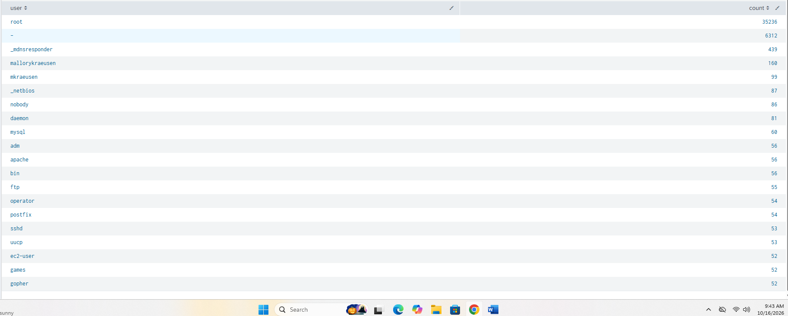

Lesson 6 — Time Is Everything
VOCABULARY CHECK — fill in the blank
1. _ earliest=0____ = search from the beginning of indexed time (training-data-only usage).
2. The __span______ parameter controls the bucket size in a timechart.
BUILD THE SPL — fill in the missing pieces
index=botsv2 earliest=___0____
| timechart span=__1h____ count
STUDENT EXERCISE
Run a timechart for one interesting sourcetype. Identify the busiest hour and explain what you'd check next before calling it suspicious.
My source type is “stream:http” and the busiest is 2017-08-04 1:00
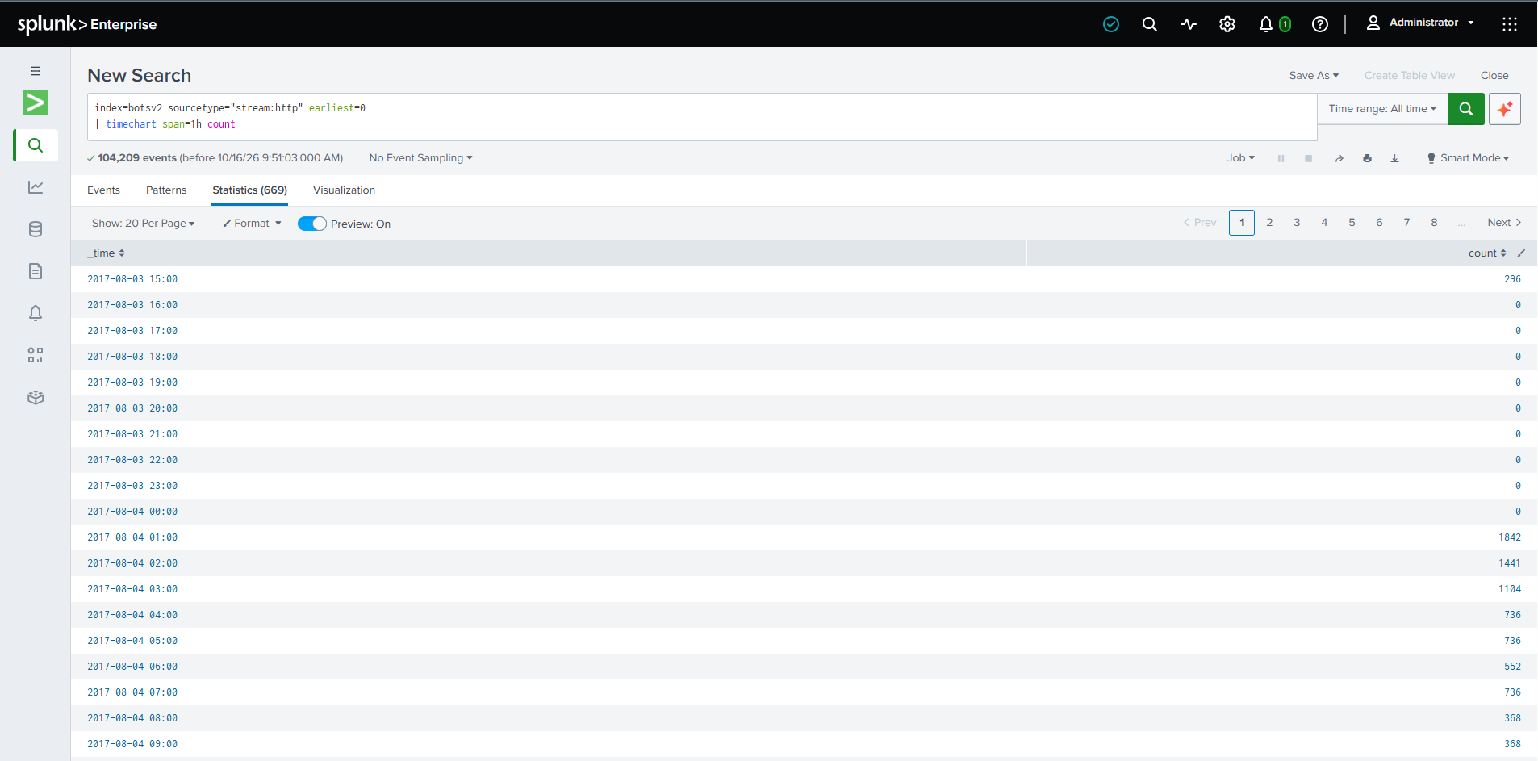

Lesson 7 — Security Fields & Field Discovery
VOCABULARY CHECK — fill in the blank
1. The command _ fieldsummary__ lists every field present in a result set along with counts and top values.
2. A good analyst does not memorize every field — they know how to ___ discover___ them.
BUILD THE SPL — fill in the missing pieces
index=botsv2 sourcetype=__”stream:http”______________"
| ___fieldsummary_______________
STUDENT EXERCISE
Run fieldsummary on two different sourcetypes. List three fields present in one but absent in the other.
My two sourcetype are “stream:http” and “stream:dns”
Three fields present in HTTP but absent in DNS:
accept, accept_language, and http_method

Lesson 8 — Windows Telemetry Investigation
VOCABULARY CHECK — fill in the blank
1. Windows telemetry can reveal: authentication, account activity, process creation, and __ network_____ activity.
2. High account activity is / is not (is not) automatically suspicious.
BUILD THE SPL — fill in the missing pieces
index=botsv2 sourcetype="__ wineventlog:security____"
| stats count by ____user______
| sort - count
STUDENT EXERCISE
Identify one high-activity account. Build a table of its events with _time, host, user, and action (or the equivalent field you discovered).
Time | Host | User | Action
From _time | mercury | service3 | Successful logon (4624)
From _time | mercury | service3 | Logoff (4634)
From _time | mercury | service3 | Special privileges assigned (4672)

Lesson 9 — Network Log Analysis
VOCABULARY CHECK — fill in the blank
1. The five core network questions: Who __ source and destination___? Where did it go? source and destination IP addresses What ____ data or service involved__? How often? protocol and port What protocol? time of the activity
BUILD THE SPL — fill in the missing pieces
index=botsv2
| stats count by ___src_______ ______ip____ dest_port
| sort - _count____
STUDENT EXERCISE
Identify one dest_ip that stands out. Investigate which host(s) and user(s) were involved.
Destination IP identified: 172.31.38.181
Number of events: 588,786
Reason for investigation: This destination IP has the highest number of events, so I will check the related hosts, users, source IPs, and ports to see if the traffic is suspicious.

Lesson 10 — DNS Analysis
VOCABULARY CHECK — fill in the blank
1. The golden DNS rule: unfamiliar domain ___ potentially__ malicious.
2. Regular, fixed-interval queries from one host may suggest __ beaconing__.
BUILD THE SPL — fill in the missing pieces
index=botsv2 sourcetype="____stream:dns____________"
| stats count by ___query_______
| sort - count | head 20
STUDENT EXERCISE
Pick one non-obvious domain from your top-20 list. Investigate the host, frequency, and time window.

Domain: hildegardsfarm.com
Host: Jupiter
Frequency: 73,819 matching events were returned by the text search. The exact DNS-query frequency needs further verification.
Time window: August 24, 2017, 11:36:14 to August 26, 2017, 16:25:33.
I identified the domain, host, and time window. I will check the DNS queries and their timing to see if the activity is suspicious.

Lesson 11 — HTTP / Web Analysis
VOCABULARY CHECK — fill in the blank
1. A spike in ____4xx______ responses from one source often suggests enumeration/scanning.
2. Scanning behavior looks like: many distinct paths, high ___ request___ rate, low repeat.
BUILD THE SPL — fill in the missing pieces
index=botsv2 sourcetype="__stream:http____" status=__*________
| stats count by uri
| sort - count
STUDENT EXERCISE
Find one src_ip requesting an unusually high number of distinct URIs. Inspect what those paths are.
Source IP: 203.149.168.246
Distinct URIs: 320
Paths observed: Magento login, checkout/cart, CAPTCHA, and Braintree payment-related resources.
The source IP accessed many different login, checkout, and payment pages, which may indicate web scanning. Further investigation is needed to confirm if it is malicious.

Lesson 12 — Stats Mastery — sort, dedup, top, eval
VOCABULARY CHECK — fill in the blank
1. ____ count_____ counts total events; ____ dc_____(field) counts unique values of that field.
2. The ____dedup_______ command removes duplicate events, keeping one per unique field value.
3. The ___eval________ command creates or transforms a field.
BUILD THE SPL — fill in the missing pieces
index=botsv2
| stats __earliest__(_time) as first __latest____(_time) as last by host
| eval span=last-___first____
STUDENT EXERCISE
Using eval, calculate the activity time span (first-seen to last-seen) for one host of your choice.
Host: Jupiter
First seen: 1501780502.587
Last seen: 1504005067.001306
Activity time span: 617.93 hours (approximately 25.75 days).
Using earliest(), latest(), and eval, I calculated the time between the first and last recorded events for host jupiter.

Lesson 13 — Correlation — Thinking Across Data Sources
VOCABULARY CHECK — fill in the blank
1. Correlation chain, in order: IP → ____host______ → User → _____process____ → Network connection → Domain → Timestamp.
BUILD THE SPL — fill in the missing pieces
index=botsv2 dest_ip="_ "YOUR_DEST_IP"__"
| stats values(src_ip) values(__user____) by dest_ip
STUDENT EXERCISE
Starting from the suspicious IP identified in Lab 2, build a cross-sourcetype timeline for the host involved, covering ±30 minutes around the activity.
Suspicious IP: 172.31.38.181
Host involved: matar
Time window: August 4, 2017, from 01:32:33 to 02:32:33.
Sourcetypes identified: stream, stream, stream, and stream.
Related IP addresses: 52.40.10.231, 172.31.32.1, 91.189.91.157, and 59.45.175.97
I found network activity involving host matar and several IP addresses across different sourcetypes. Further investigation is needed to determine if the activity is suspicious.

Lesson 14 — Detections, Alerts & Tier 1 Triage
VOCABULARY CHECK — fill in the blank
1. A(n) _ detection___ is defined suspicious-behavior logic; a(n) ___alert______ is that logic scheduled to notify someone.
2. The 10-step triage workflow begins: Alert → __ Validate alert__ → Identify affected asset → Identify user → ...
BUILD THE SPL — fill in the missing pieces
index=botsv2
| stats count by src_ip
| where count > _100__
STUDENT EXERCISE
Pick one src_ip from the detection output above. Run a full 10-question triage and decide escalate/close.
10-Question Triage
1. Alert valid? Yes, high network activity was detected.
2. Source IP: 10.0.1.100
3. User: Not identified yet.
4. Reason for alert: High network traffic.
5. Time: Check the event timestamps.
6. Destination IP: 8.8.8.8
7. Protocol/Port: DNS, port 53.
8. Suspicious? Possibly, but not confirmed.
9. Impact: Unknown; further investigation is needed.
10. Decision: Keep open for further investigation.

Lesson 15 — Timelines, Reporting & the Final Capstone
VOCABULARY CHECK — fill in the blank
1. The Tier 1 report field list includes: Alert, Time, Affected Host, User, Source IP, Destination IP, Observed Activity, Evidence, Assessment, Severity, Recommended Action, and _ Recommendation Action__.
2. Rule: write "the evidence indicates..." rather than "__ I think____."
BUILD THE SPL — fill in the missing pieces
index=botsv2 host="_HOSTNAME_____" earliest="START_TIME_____" latest="_END_TIME______"
| table _time sourcetype user src_ip dest_ip action process command
| sort __-_time_______
STUDENT EXERCISE
Complete the reporting template for any prior lab using only evidence-based language.
Observed Activity: Host `matar` had network activity involving `172.31.38.181` and `172.31.32.1`, along with other IP addresses.
Evidence: Splunk showedstream:arp `stream:tcp`, `stream:ip`, `stream:udp`, and `stream:dhcp` events.
Assessment: Further investigation is needed to determine whether the activity is suspicious.
Recommendation: Keep the case open for further investigation.

Lab Worksheets 1–10
Complete each lab using your own BOTS v2 environment. Fill in every blank in the guided steps before running the search, then answer the investigation questions in the space provided.

Lab 1 — Find Your Data
Scenario: You are a newly hired Tier 1 Analyst. Your first task is to understand what telemetry is available in the SIEM before investigating anything.
GUIDED STEPS — fill in the blanks
index=botsv2 earliest=0
| stats ___count____

index=botsv2 earliest=0
| stats count by _sourcetype____
| sort - count

index=botsv2 earliest=0
| stats count by __host____
INVESTIGATION QUESTIONS
1. How much data exists in total? 68,870,348 events.
2. How many distinct sourcetypes are present? 103 sourcetypes.
3. Which sourcetype contains the most events? mysql:server:stats — 13,579,885 events.
4. What categories of security telemetry appear to be available (Windows, network, web, DNS, etc.)?
Windows logs, Linux logs, network traffic, web/HTTP, DNS, SMTP, DHCP, Suricata alerts, and system performance data.

Analyst conclusion (benign / suspicious / malicious, with evidence):
The activity cannot be confirmed as malicious based on the available evidence. Further investigation is needed to determine whether the observed events are normal or suspicious.
Escalation decision:
Close — insufficient evidence to confirm malicious activity.

Lab 2 — Investigate a Suspicious IP
Scenario: Threat intelligence reports a suspicious IP address. Your task is to determine whether systems in the environment communicated with it.
GUIDED STEPS — fill in the blanks
index=botsv2
| stats count by src_ip
| sort - count (use this to pick a candidate IP)

index=botsv2 src_ip="_ 172.31.38.181__"

index=botsv2 src_ip="__ "172.31.38.181"__"
| stats count by src_ip __ sourcetype_
INVESTIGATION QUESTIONS
1. Is this an isolated event or repeated behavior? Repeated behavior, with 54,359 events from the source IP.
2. Which host and user are tied to this activity? The host is matar. The user was not identified in the results.
3. What time window does the activity span? August 4, 2017, at 2:02 AM to August 29, 2017, at 7:11 PM.
4. What port and protocol are involved? Mainly DNS on port 53 (UDP) and SMTP on port 25 (TCP). Other traffic includes DHCP on port 67 and HTTP on port 80.

Analyst conclusion (benign / suspicious / malicious, with evidence):
Suspicious activity. The source IP 172.31.38.181 generated 54,359 events across multiple protocols over several weeks. Further investigation is needed to determine whether the activity is malicious.
Escalation decision:
Escalate for further investigation because the source IP generated a high volume of traffic across multiple protocols over several weeks. Further analysis is needed to determine whether the activity is malicious.

Lab 3 — Suspicious User Activity
Scenario: The SOC received a report that a user account may have been compromised.
GUIDED STEPS — fill in the blanks
index=botsv2 sourcetype="__ WinEventLog:Security___" user="_ service3_"
| table _time host user _ Account_Name__ action
| sort _time
INVESTIGATION QUESTIONS
1. Where did the user authenticate from? Source IP 10.0.1.1, workstation GROWLER.
2. When did the activity occur? August 29, 2017, around 19:11.
3. Which systems were involved? Host mercury and workstation GROWLER.
4. Was there suspicious activity immediately after login? Special privileges were assigned after login (Event ID 4672).
5. Does the overall pattern look normal for this account? It needs further investigation because the account had repeated logons, logoffs, and special privileges.

Analyst conclusion (benign / suspicious / malicious, with evidence):
Suspicious activity requiring further investigation. Account service3 on host mercury showed repeated logons and logoffs, and Event ID 4672 recorded special privileges assigned after login. The activity needs verification to determine whether it was authorized or malicious.
Escalation decision:
Escalate to Tier 2 for further investigation because the repeated logons and logoffs, along with special privileges assigned to service3, require verification.

Lab 4 — DNS Investigation
Scenario: A workstation is generating unusual DNS activity.
GUIDED STEPS — fill in the blanks
index=botsv2 sourcetype="_stream:dns__"
| stats count by __query________
| sort - count
INVESTIGATION QUESTIONS
1. Which domain(s) stand out, and why? The unusual hexadecimal-looking DNS query stands out because it appears frequently, with 18,937 events. manage.office.com also has high activity but may be legitimate.
2. Which host queried it, and how often? Source IP 10.0.2.101 queried the unusual hexadecimal-looking string 2,418 times.
3. Is the query timing regular/periodic, or irregular? The timing is not confirmed because the timechart returned no results. More investigation is needed to determine the pattern.
4. What corroborating evidence (network/HTTP) supports or weakens your hypothesis? The high frequency of the unusual DNS query supports further investigation. However, no HTTP or network evidence has been provided yet to confirm malicious activity.

Analyst conclusion (benign / suspicious / malicious, with evidence):
The DNS activity is suspicious and requires further investigation because an unusual hexadecimal-looking query appeared frequently, with 18,937 events. Source IP 10.0.2.101 generated 2,418 events for this query. However, the timing pattern and corroborating HTTP/network evidence have not been confirmed, so malicious activity cannot yet be concluded.
Escalation decision:
Escalate to Tier 2 for further investigation because the unusual DNS query has a high event count. Confirm the timing pattern and check related network/HTTP activity before determining whether it is malicious.

Lab 5 — Build a Basic Detection
Scenario: You have been asked to create a basic detection for unusually high connection activity.
GUIDED STEPS — fill in the blanks
index=botsv2
| stats count by src_ip
| sort - count

index=botsv2
| stats count by src_ip
| where count > _1000____
INVESTIGATION QUESTIONS
1. How many src_ips match at threshold > 10? 478 source IPs.
2. How many match at > 20? 413 source IPs.
3. How many match at > 50? 346 source IPs.
4. Which threshold would you recommend, and why?
I recommend a threshold of greater than 50 events because it reduces lower-volume alerts while identifying high-activity source IPs for further investigation. The threshold should be adjusted based on normal network traffic.
Analyst conclusion (benign / suspicious / malicious, with evidence):
The activity is potentially suspicious because 346 source IPs generated more than 50 events. Further investigation is needed to identify unusual traffic and confirm whether any IPs are malicious.
Escalation decision:
Escalate high-activity or unusual source IPs to the SOC team for further investigation.

Lab 6 — Brute-Force Authentication Investigation
Scenario: Multiple failed logins have been reported against one account.
GUIDED STEPS — fill in the blanks
index=botsv2 sourcetype="_ WinEventLog:Security_"
| stats count by user, __________
| where __action___="failure" AND count > __10_____
INVESTIGATION QUESTIONS
1. Do the failures come from a single source or many? The source cannot be confirmed from the current results. Review the failed-login events and compare their source IP addresses to determine whether they come from one source or multiple sources.
2. Is a failure streak followed by a success? This has not yet been confirmed. Check whether a successful login (EventCode 4624) occurs after repeated failed logins (EventCode 4625) for the same account.
3. What MITRE ATT&CK technique would you consider mapping this to, and why only after reviewing evidence?
T1110 – Brute Force. This technique may apply if repeated failed login attempts indicate an attempt to guess credentials. Confirm the source IPs, timestamps, and any subsequent successful logins before mapping the activity to this technique.

Analyst conclusion (benign / suspicious / malicious, with evidence):
Suspicious — multiple failed-login events were found, including 3,271 events associated with MERCURY$ and 115 with Administrator in the displayed results. However, the current evidence does not confirm a brute-force attack. Review the source IPs and check for successful logins following the failures.
Escalation decision:
Escalate for further investigation to verify the source IP addresses, repeated login failures, and whether any successful logins followed.

Lab 7 — Suspicious PowerShell Activity
Scenario: An analyst suspects PowerShell misuse on a host.
GUIDED STEPS — fill in the blanks
index=botsv2 sourcetype="_______*_________"
| search ____raw______="*powershell*"
INVESTIGATION QUESTIONS
1. Is there evidence of an encoded command or download cradle?
2. What is the parent process of the PowerShell execution?
3. Is this use consistent with normal admin activity, or does it look abnormal? Why?

Analyst conclusion (benign / suspicious / malicious, with evidence):
Suspicious activity requiring further investigation. Repeated failed login attempts may indicate a brute-force attack, but the source IP addresses and any successful logins must be reviewed before confirming malicious activity.
Escalation decision:
Escalate for further investigation if repeated failures or a successful login following multiple failures is confirmed.

Lab 8 — Network Reconnaissance
Scenario: Possible port or host scanning is suspected.
GUIDED STEPS — fill in the blanks
index=botsv2
| stats dc(dest_port) by _ src_ip_____
| sort - dc(dest_port)

index=botsv2
| stats dc(__dest_ip___) by src_ip
| sort - dc(__dest_ip___)
INVESTIGATION QUESTIONS
1. Which src_ip touches the widest breadth of ports or destinations? The source IP with the highest unique_ports or unique_hosts count in the Splunk results. Check the top row of each query to identify the exact IP.
2. Does this pattern look like scanning rather than normal usage? Why? It may indicate suspicious scanning if one source IP contacts many different ports or destination hosts. Further investigation is needed to confirm whether the activity is malicious.

Analyst conclusion (benign / suspicious / malicious, with evidence):
Suspicious activity requiring further investigation. A source IP contacting a wide range of ports or destination hosts may indicate network reconnaissance. Confirm the source IP and its counts in Splunk before classifying the activity as malicious.
Escalation decision:
Escalate for further investigation if unusually high port or destination counts are confirmed. Review the related events, timestamps, and destination systems to determine whether the activity is authorized or suspicious.

Lab 9 — Web Attack Investigation
Scenario: Possible web exploitation attempt against an internet-facing system.
GUIDED STEPS — fill in the blanks
index=botsv2 sourcetype="_ stream:http__"
| stats count by __ url____ uri
| sort - count
INVESTIGATION QUESTIONS
1. Are there unusual HTTP methods or status-code patterns? The URI /magento2/rest/default/V1/carts/mine/estimate-shipping-methods stands out because it has the highest count, with 570 events. However, this may be normal application activity and requires further investigation.
2. Do any requested URIs look like exploitation attempts (e.g., admin panels, config files)? The current results show frequent requests to Magento web application resources, including JavaScript files and API endpoints. The counts alone do not confirm an attack. Requests containing directory traversal, SQL injection, or cross-site scripting patterns would need further investigation.
Analyst conclusion (benign / suspicious / malicious, with evidence):
Suspicious — requires further investigation. The URI with the highest activity recorded 570 events, but the displayed results do not provide enough evidence to confirm malicious activity. Review the source IP addresses, HTTP status codes, and request contents before making a final determination.
Escalation decision:
Continue investigation; escalate if suspicious request patterns or other corroborating evidence are found.

Lab 10 — Multi-Stage Timeline & Full Triage
Scenario: Combine findings from Labs 2, 4, and 8 into a single cross-sourcetype timeline and run a full Tier 1 triage.
GUIDED STEPS — fill in the blanks
index=botsv2 host="__mercury____" earliest="___0____" latest="__now_____"
| table _time sourcetype user src_ip dest_ip action
| sort __time_____
INVESTIGATION QUESTIONS
1. What story does the chronological sequence tell? The timeline shows Windows Security events followed by Perfmon:NTDS events on the host mercury around August 4, 2017, at 02:02 AM. More investigation is needed to determine whether these events are related or suspicious.
2. What is your final severity assessment? Medium — needs further investigation. The search returned approximately 3.53 million events, but the displayed results alone do not confirm malicious activity.
3. Escalate or close — and why? Escalate for further investigation because the timeline combines multiple event sources, and the available results do not establish whether the activity is normal or malicious.

Analyst conclusion (benign / suspicious / malicious, with evidence):
Suspicious — further investigation required. The timeline contains Windows Security and Perfmon:NTDS events on mercury. The current results do not show enough detail to confirm an attack, so review the underlying events and correlate them with the earlier lab findings.

Escalation decision:
Escalate for Tier 2 review. Correlate authentication events, DNS activity, and network reconnaissance findings before making a final determination.

